# Gannt Chart

## Textual Representation

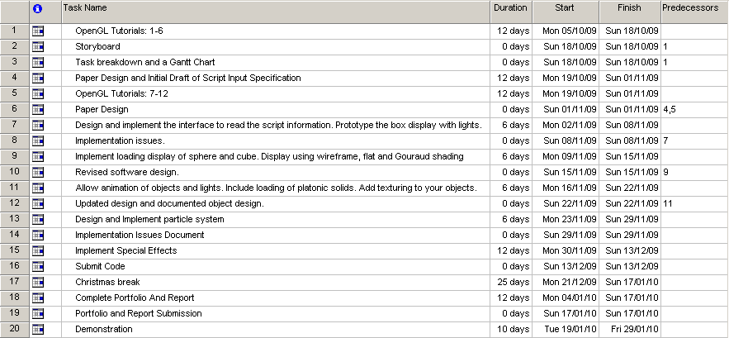

## Graphical Representation

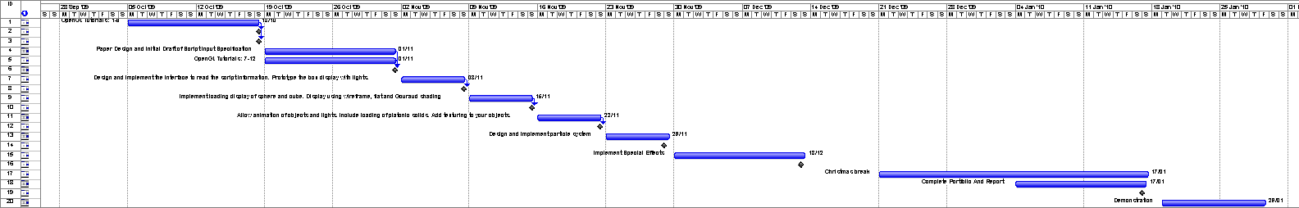

**Additional Information**

The Gannt chart was created using Microsoft Project 2007.